# Trace Stewart

Guillermo Galvez

CPE301 – SPRING 2018

Midterm 2

**DO NOT REMOVE THIS PAGE DURING SUBMISSION:**

The student understands that all required components should be submitted in complete for grading of this assignment.

|  |  |  |  |
| --- | --- | --- | --- |
| **NO** | **SUBMISSION ITEM** | **COMPLETED (Y/N)** | **MARKS**  **(/MAX)** |
| 1 | COMPONENTS LIST AND CONNECTION BLOCK DIAGRAM w/ PINS |  |  |
| 2. | INITIAL CODE OF TASK 1/A |  |  |
| 3. | INCREMENTAL / DIFFERENTIAL CODE OF TASK 2/B |  |  |
| 3. | INCREMENTAL / DIFFERENTIAL CODE OF TASK 3/C |  |  |
| 3. | INCREMENTAL / DIFFERENTIAL CODE OF TASK 4/D |  |  |
| 3. | INCREMENTAL / DIFFERENTIAL CODE OF TASK 5/E |  |  |
| 4. | SCHEMATICS |  |  |
| 5. | SCREENSHOTS OF EACH TASK OUTPUT |  |  |
| 5. | SCREENSHOT OF EACH DEMO |  |  |
| 6. | VIDEO LINKS OF EACH DEMO |  |  |
| 7. | GOOGLECODE LINK OF THE DA |  |  |
|  |  |  |  |
|  |  |  |  |

1. **COMPONENTS LIST AND CONNECTION BLOCK DIAGRAM w/ PINS**

The Components used in this lab we 2 Atmega 328p’s and 2 NRF24l01 modules.

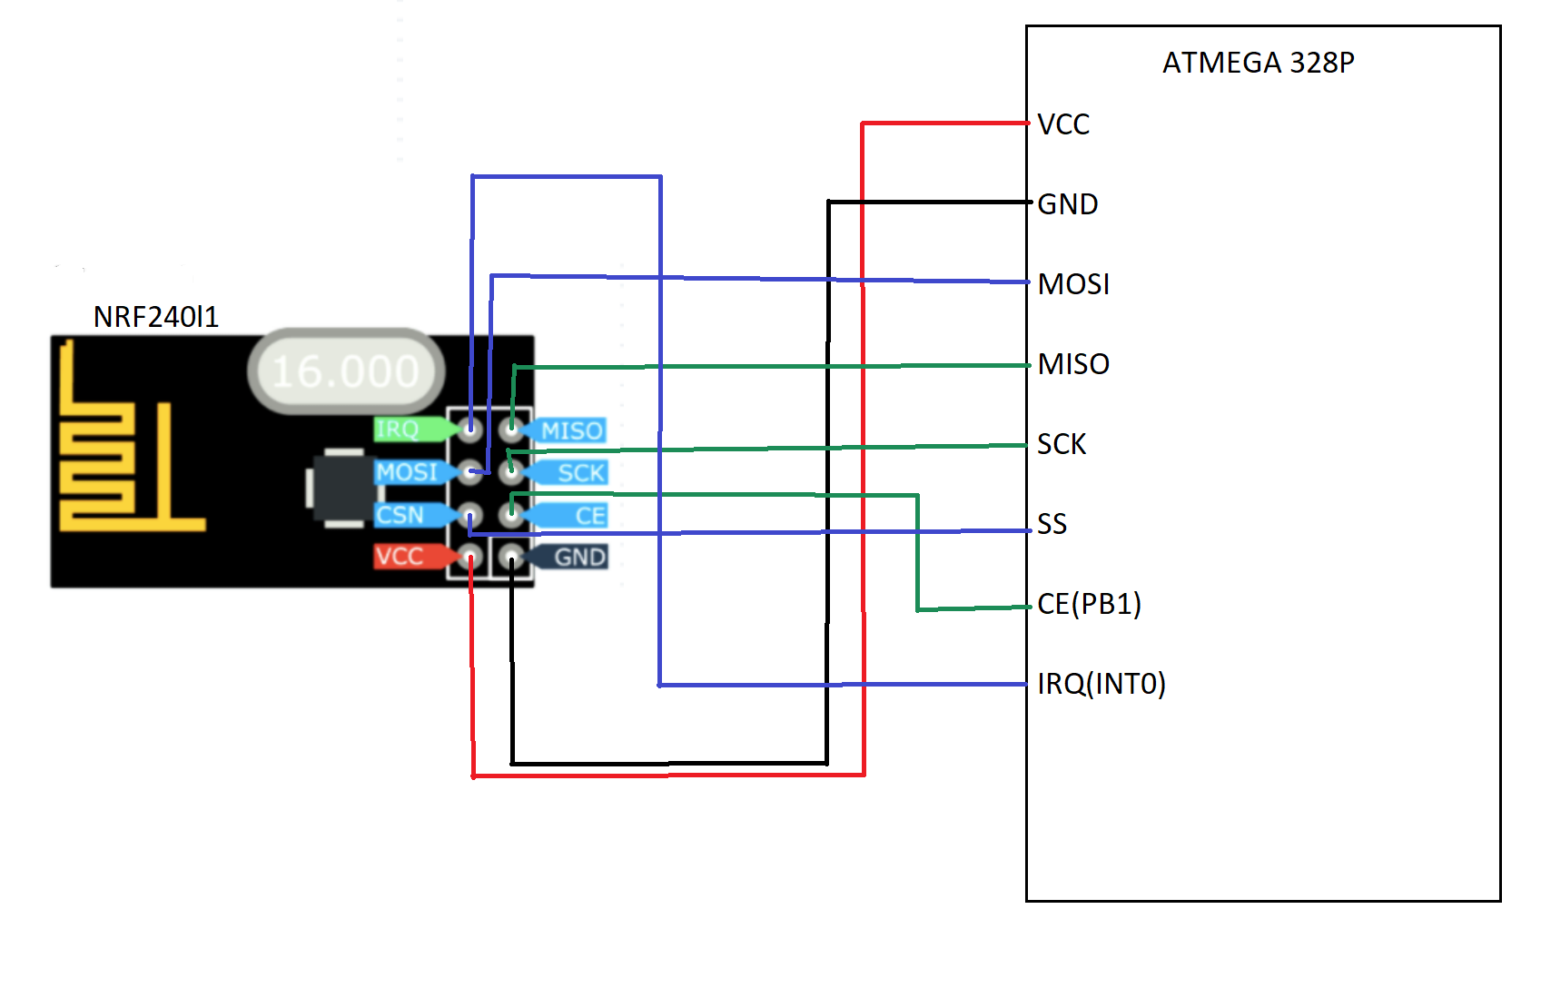

1. **INITIAL/DEVELOPED CODE OF TASK 1**

/*

* Midterm2_Transmit.c

*

* Created: 4/12/2018 8:55:33 AM

* Author : trace / guillermo

*/

#include <avr/io.h>

#include <avr/interrupt.h>

#include <stdbool.h>

#include <string.h>

#include "nrf24l01.h"

#include "nrf24l01-mnemonics.h"

#include <util/delay.h>

#define F_CPU 1000000UL

#define FOSC 16000000

#define BAUD 9600

#define MYUBRR FOSC/16/BAUD-1

void setup_timer(void);

nRF24L01 *setup_rf(void);

void initUART();

void ADC_Init();

void writeChar(char *c);

void USART_Init();

volatile bool rf_interrupt = false;

volatile bool send_message = false;

volatile uint8_t adcValue;

char seeTemp[3];

char *seeTemp2;

int main(void) {

uint8_t to_address[5] = { 0x78, 0x78, 0x78, 0x78, 0x78 };

bool on = false;

ADC_Init();

setup_timer();

USART_Init();

nRF24L01 *rf = setup_rf();

while (true) {

if (rf_interrupt) {

rf_interrupt = false;

int success = nRF24L01_transmit_success(rf);

if (success != 0)

nRF24L01_flush_transmit_message(rf);

}

if (send_message) {

send_message = false;

on = !on;

nRF24L01Message msg;

if (on)

{

memcpy(msg.data, seeTemp2, 3);

}

msg.length = strlen((char *)msg.data) + 1;

writeChar(msg.data);

nRF24L01_transmit(rf, to_address, &msg);

}

}

return 0;

}

nRF24L01 *setup_rf(void) {

nRF24L01 *rf = nRF24L01_init();

rf->ss.port = &PORTB;

rf->ss.pin = PB2;

rf->ce.port = &PORTB;

rf->ce.pin = PB1;

rf->sck.port = &PORTB;

rf->sck.pin = PB5;

rf->mosi.port = &PORTB;

rf->mosi.pin = PB3;

rf->miso.port = &PORTB;

rf->miso.pin = PB4;

// interrupt on falling edge of INT0 (PD2)

EICRA |= _BV(ISC01);

EIMSK |= _BV(INT0);

nRF24L01_begin(rf);

return rf;

}

// setup timer to trigger interrupt every second when at 1MHz

void setup_timer(void) {

TCCR1B |= _BV(WGM12);

TIMSK1 |= _BV(OCIE1A);

TIMSK1 |= _BV(TOIE1);

OCR1A = 15624;

//OCR1A = 33000;

TCCR1B |= _BV(CS10) | _BV(CS11);

}

//ADC initialization function

void ADC_Init()

{

// initialize ADC

DDRC = 0; // Set PORTC as input for adc

DIDR0 = 0x1; // Disable digital input on ADC0 pin

ADMUX = 0; // ADC0 (PC.0) used as analog input

ADMUX |= (1 << REFS0); // use AVcc as the reference

ADMUX |= (1 << ADLAR); // Right adjust for 8 bit resolution

ADCSRA = 0x87; // Enable ADC, system clock, 10000111

ADCSRB = 0x0; // Free running mode

sei(); //enable global interrupts

}//end ADC_Init

// each one second interrupt

ISR(TIMER1_COMPA_vect) {

send_message = true;

char temperature[6];

TIFR1 |= (1 << TOV1); //Clr Flag

//fifteenPlus++;

float lm34_0; //For ASCII Temp output

ADCSRA |= (1 << ADSC); //Start Conversion

while((ADCSRA & (1 << ADIF)) == 0); //Wait for conversion to finish

//Conversion to °F

lm34_0 = (ADCH * 5.0 / 0x100) * 100.0; //(ADC * 5 = 200 /256) * 100

dtostrf(lm34_0, 3, 0, temperature); //Float to char conversion

seeTemp2 = temperature;

}

// nRF24L01 interrupt

ISR(INT0_vect) {

rf_interrupt = true;

}

void writeChar(char *c) {

int i = 0;

while(i<3){

UDR0 = c[i]; // Display character on serial (i.e., PuTTY) terminal

_delay_ms(10); // delay for 200 ms

i++;

}

}

void USART_Init()

{

/*Set Baud Rate*/

UBRR0H = (MYUBRR>>8); //Shift MSB "top" of UBRR0H 0100 0100 >> 8 -> UBRR0H 0000 0000

UBRR0L = MYUBRR; //UBRR0L 0100 0100

UCSR0B |= (1 << RXEN0) | (1 << TXEN0); //Enable Rec and Trans

UCSR0B |= (1 << RXCIE0); //Enable Rec INT

UCSR0C |= (1 << UCSZ01) | (1 << UCSZ00); //Set frame 8-bit, 1 STP

}//end USART_int

/*

* Midterm2_Receive.c

*

* Created: 4/15/2018 2:47:49 PM

* Author : trace / guillermo

*/

#include <avr/io.h>

#include <avr/interrupt.h>

#include <stdbool.h>

#include <string.h>

#include <util/delay.h>

#include <stdlib.h>

#include "nrf24l01.h"

#include "nrf24l01-mnemonics.h"

#define F_CPU 1000000UL

#define FOSC 16000000

#define BAUD 9600

#define MYUBRR FOSC/16/BAUD-1

nRF24L01 *setup_rf(void);

void process_message(char *message);

inline void prepare_led_pin(void);

inline void set_led_high(void);

inline void set_led_low(void);

void USART_Init();

void writestring(char *c);

void writeChar(unsigned char c);

volatile bool rf_interrupt = false;

int main(void) {

USART_Init(); // Initialize UART

bool on = false;

uint8_t address[5] = { 0x78, 0x78, 0x78, 0x78, 0x78 };

prepare_led_pin();

sei();

nRF24L01 *rf = setup_rf();

nRF24L01_listen(rf, 0, address);

uint8_t addr[5];

nRF24L01_read_register(rf, CONFIG, addr, 1);

while (true) {

if (rf_interrupt) {

rf_interrupt = false;

while (nRF24L01_data_received(rf)) {

nRF24L01Message msg;

nRF24L01_read_received_data(rf, &msg);

process_message((char *)msg.data);

if(true){

writestring("Temperature: ");

writestring(msg.data);

writestring("F");

writestring("\r");

}

}

nRF24L01_listen(rf, 0, address);

}

}

return 0;

}

void USART_Init()

{

/*Set Baud Rate*/

UBRR0H = (MYUBRR>>8); //Shift MSB "top" of UBRR0H 0100 0100 >> 8 -> UBRR0H 0000 0000

UBRR0L = MYUBRR; //UBRR0L 0100 0100

UCSR0B |= (1 << RXEN0) | (1 << TXEN0); //Enable Rec and Trans

UCSR0B |= (1 << RXCIE0); //Enable Rec INT

UCSR0C |= (1 << UCSZ01) | (1 << UCSZ00); //Set frame 8-bit, 1 STP

}//end USART_int

void writeChar(unsigned char c) {

UDR0 = c; // Display character on serial (i.e., PuTTY) terminal

_delay_ms(400); // delay for 200 ms

}

void writestring(char *c){

unsigned int i = 0;

while(c[i] != 0)

writeChar(c[i++]);

}

nRF24L01 *setup_rf(void) {

nRF24L01 *rf = nRF24L01_init();

rf->ss.port = &PORTB;

rf->ss.pin = PB2;

rf->ce.port = &PORTB;

rf->ce.pin = PB1;

rf->sck.port = &PORTB;

rf->sck.pin = PB5;

rf->mosi.port = &PORTB;

rf->mosi.pin = PB3;

rf->miso.port = &PORTB;

rf->miso.pin = PB4;

// interrupt on falling edge of INT0 (PD2)

EICRA |= _BV(ISC01);

EIMSK |= _BV(INT0);

nRF24L01_begin(rf);

return rf;

}

void process_message(char *message) {

if (strcmp(message, "ON") == 0)

set_led_high();

else if (strcmp(message, "OFF") == 0)

set_led_low();

}

inline void prepare_led_pin(void) {

DDRB |= _BV(PB0);

PORTB &= ~_BV(PB0);

}

inline void set_led_high(void) {

PORTB |= _BV(PB0);

}

inline void set_led_low(void) {

PORTB &= _BV(PB0);

}

// nRF24L01 interrupt

ISR(INT0_vect) {

rf_interrupt = true;

}

1. **SCHEMATICS**

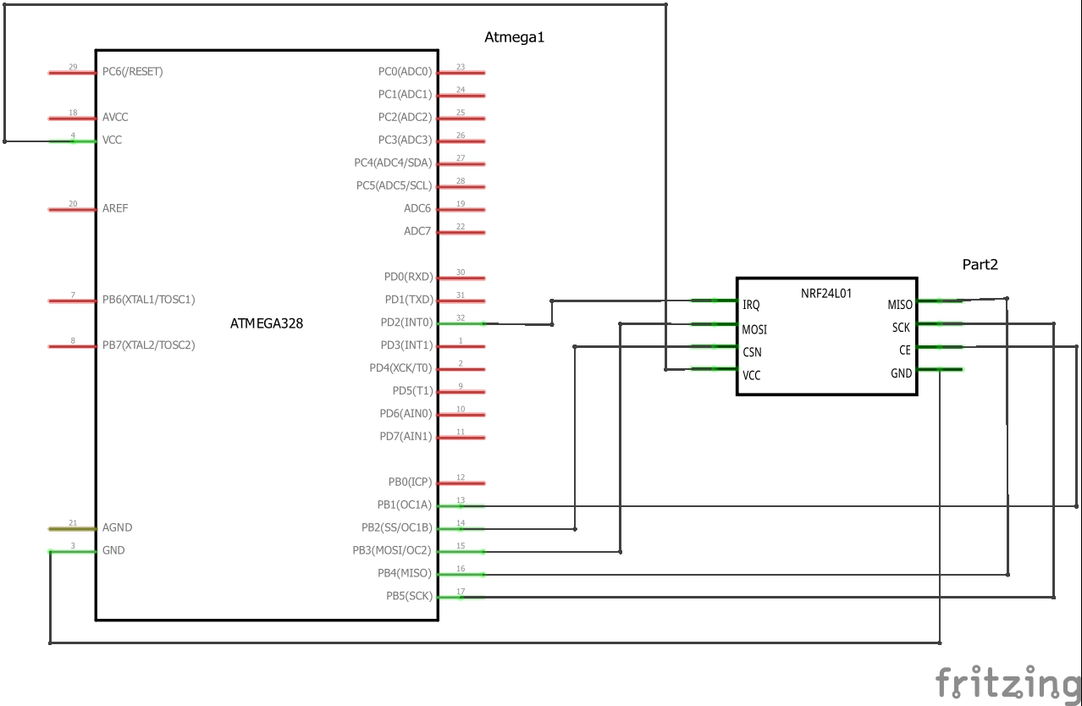

Figure 1: Receiver Schematic

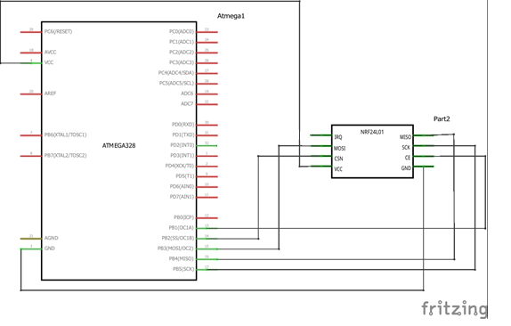

Figure 2: Sender Schematic

1. **SCREENSHOTS OF EACH TASK OUTPUT (ATMEL STUDIO OUTPUT)**

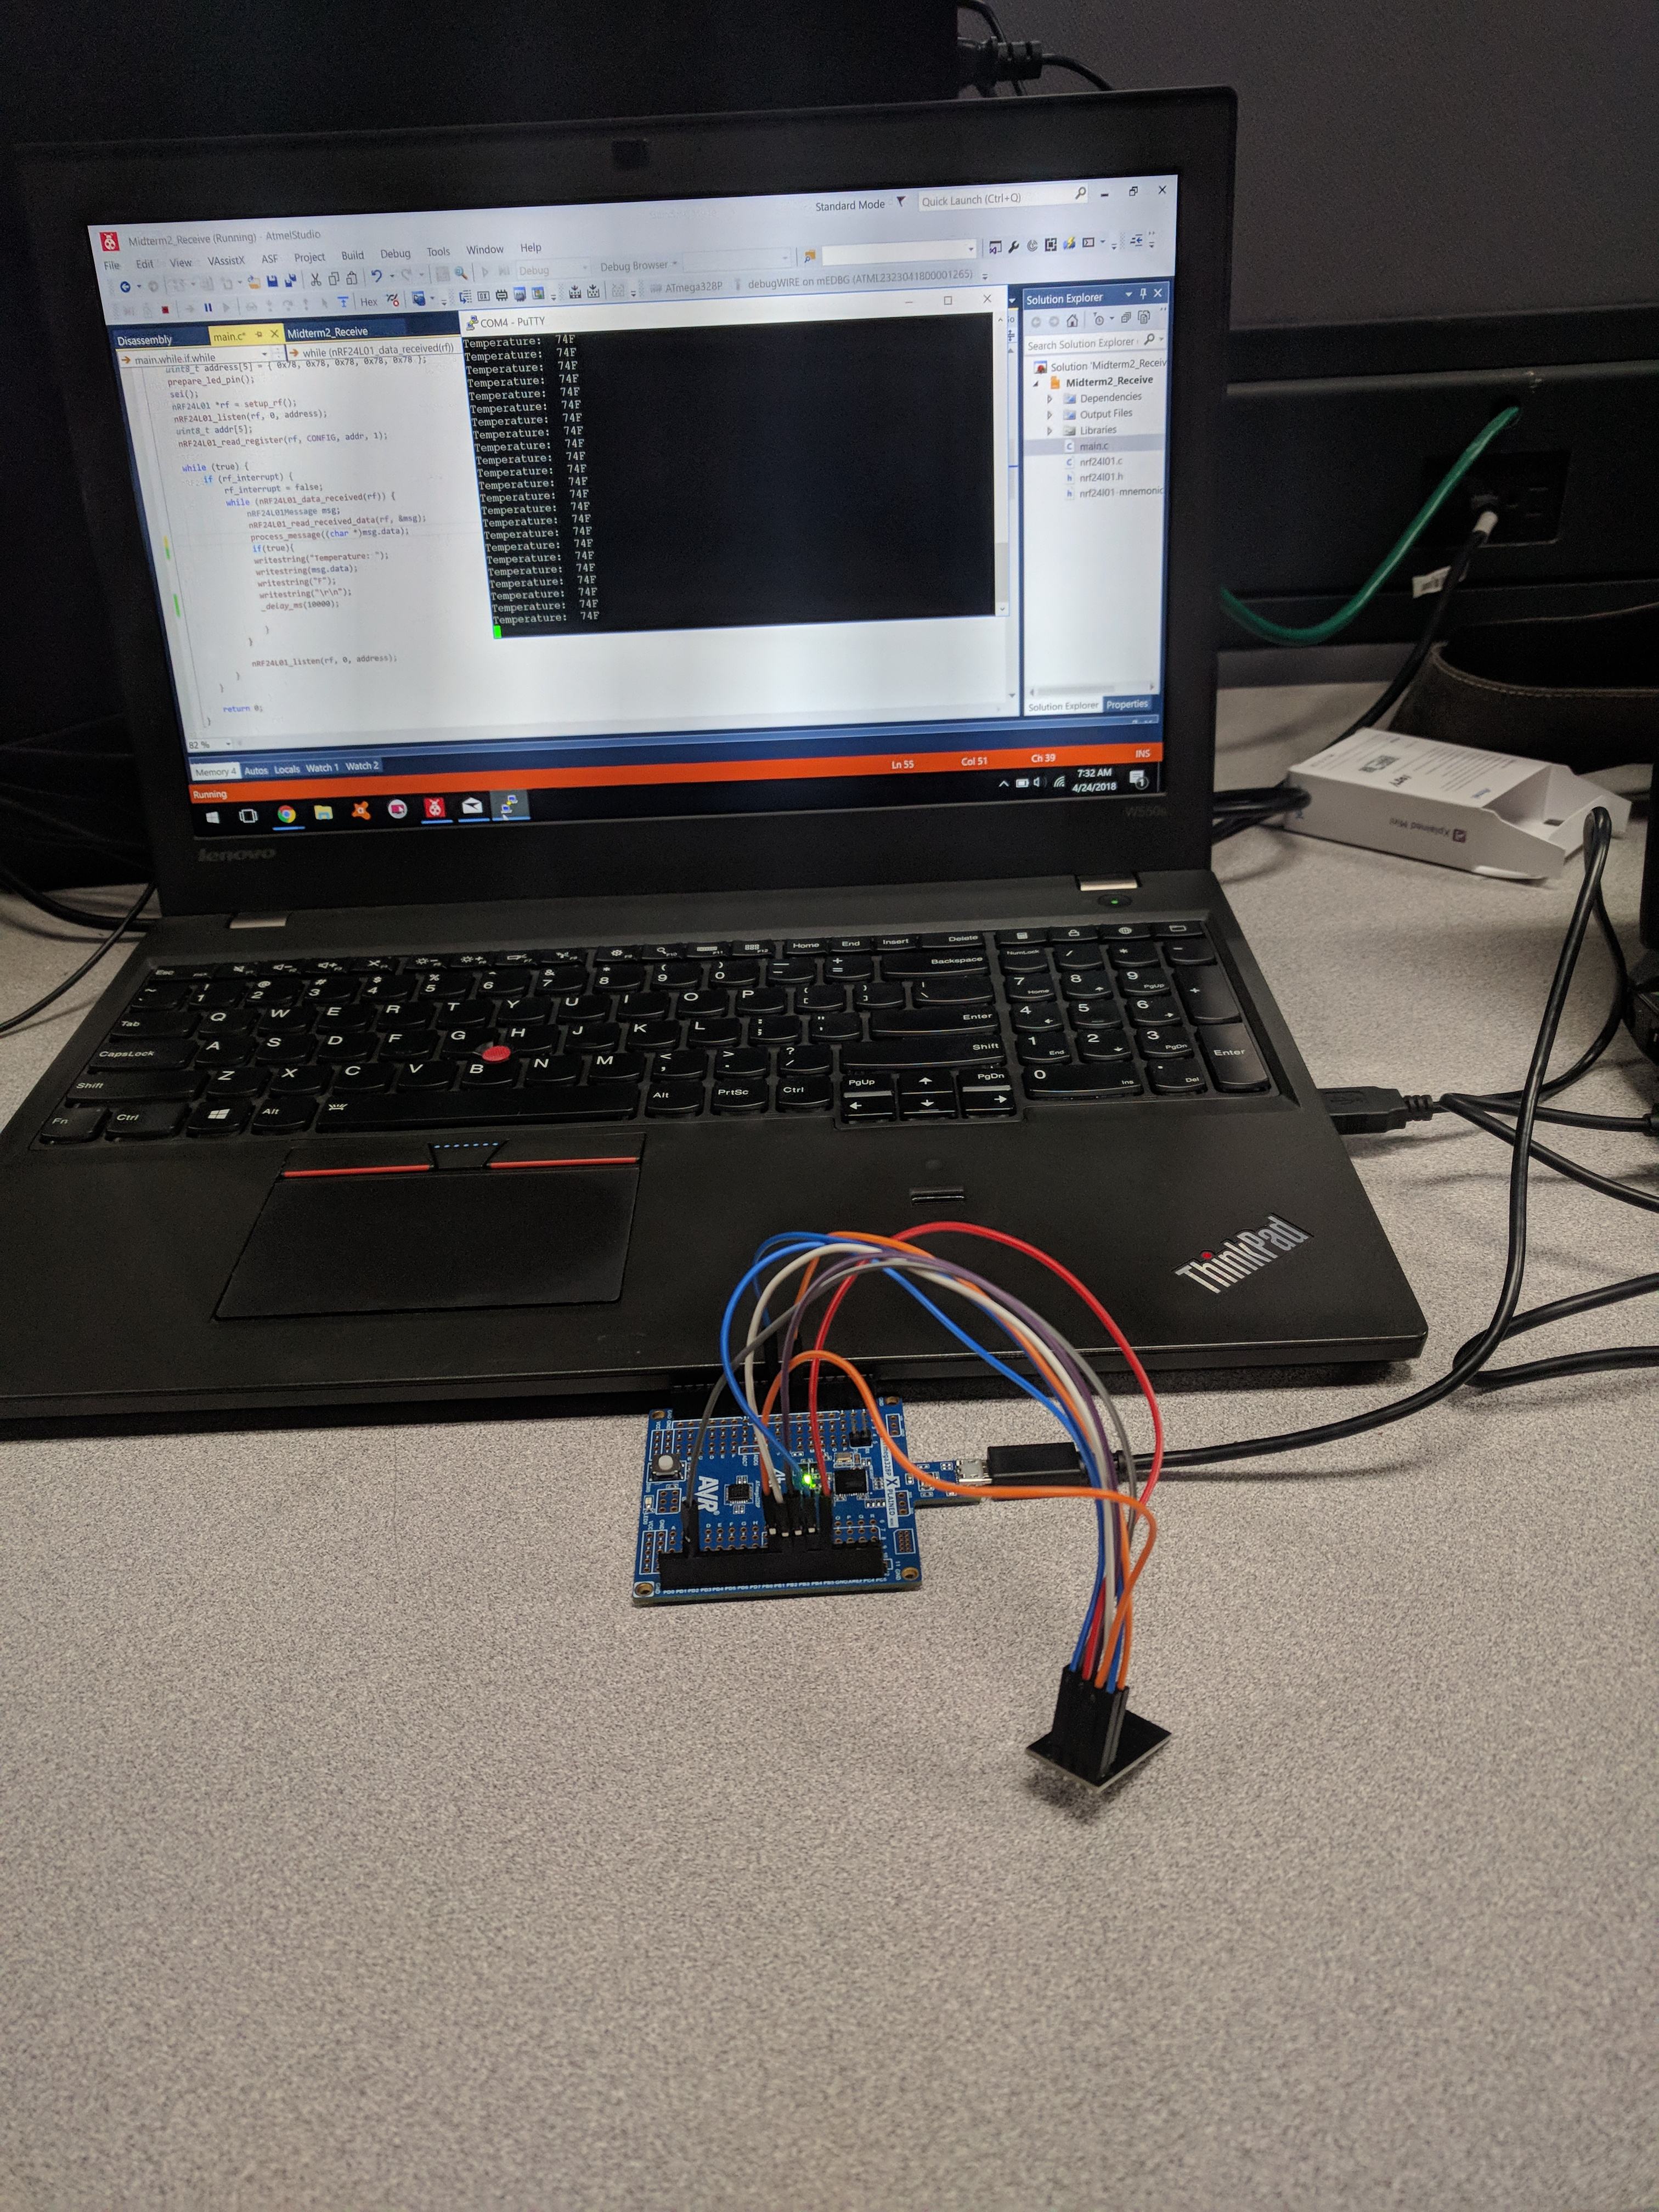

Figure 3: Putty output from Receiver

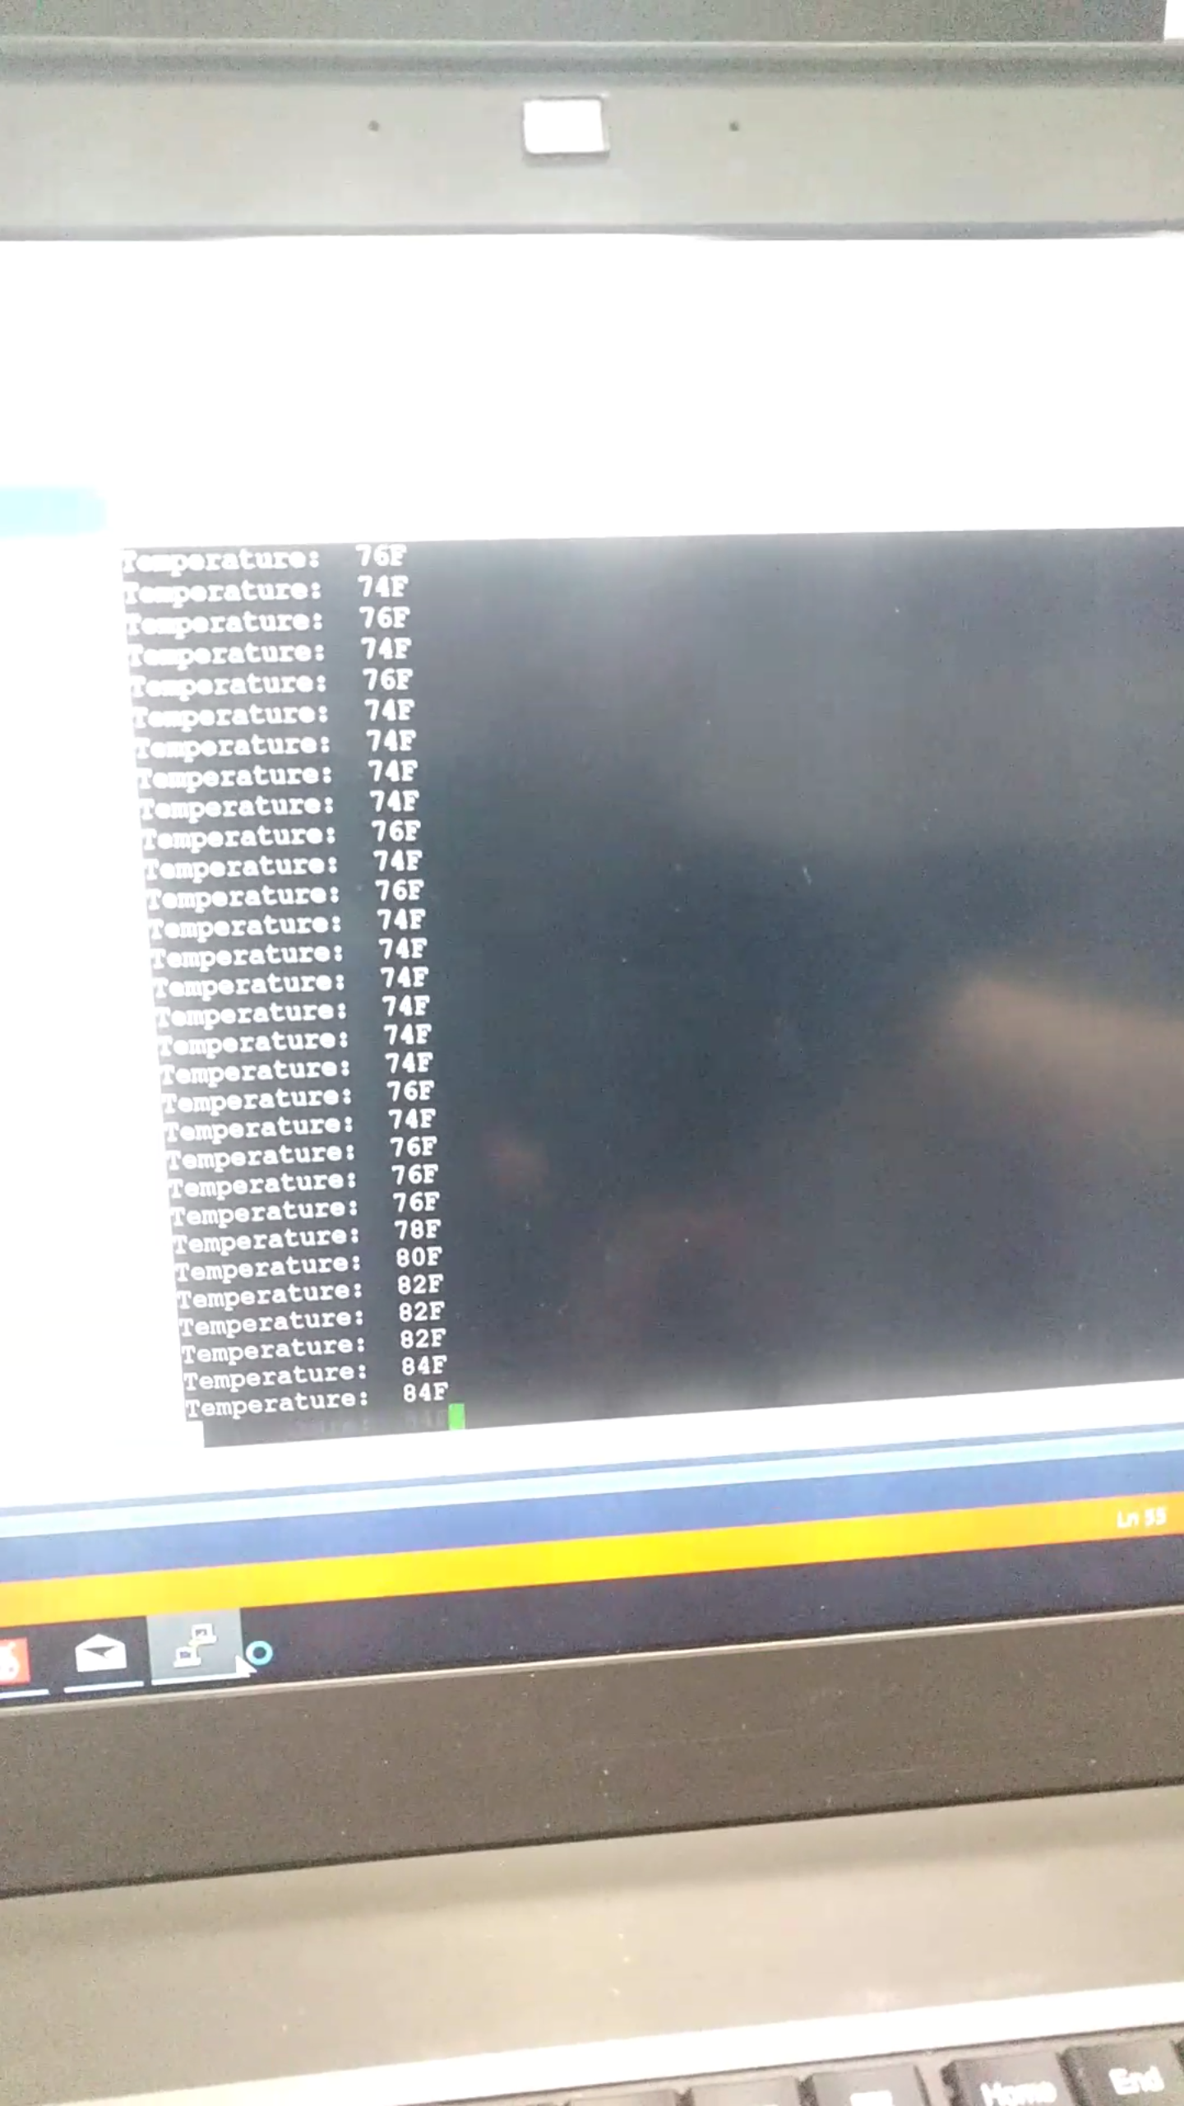

Figure 4: Putty output from receiver

1. **SCREENSHOT OF EACH DEMO (BOARD SETUP)**



Figure 5: Receiver

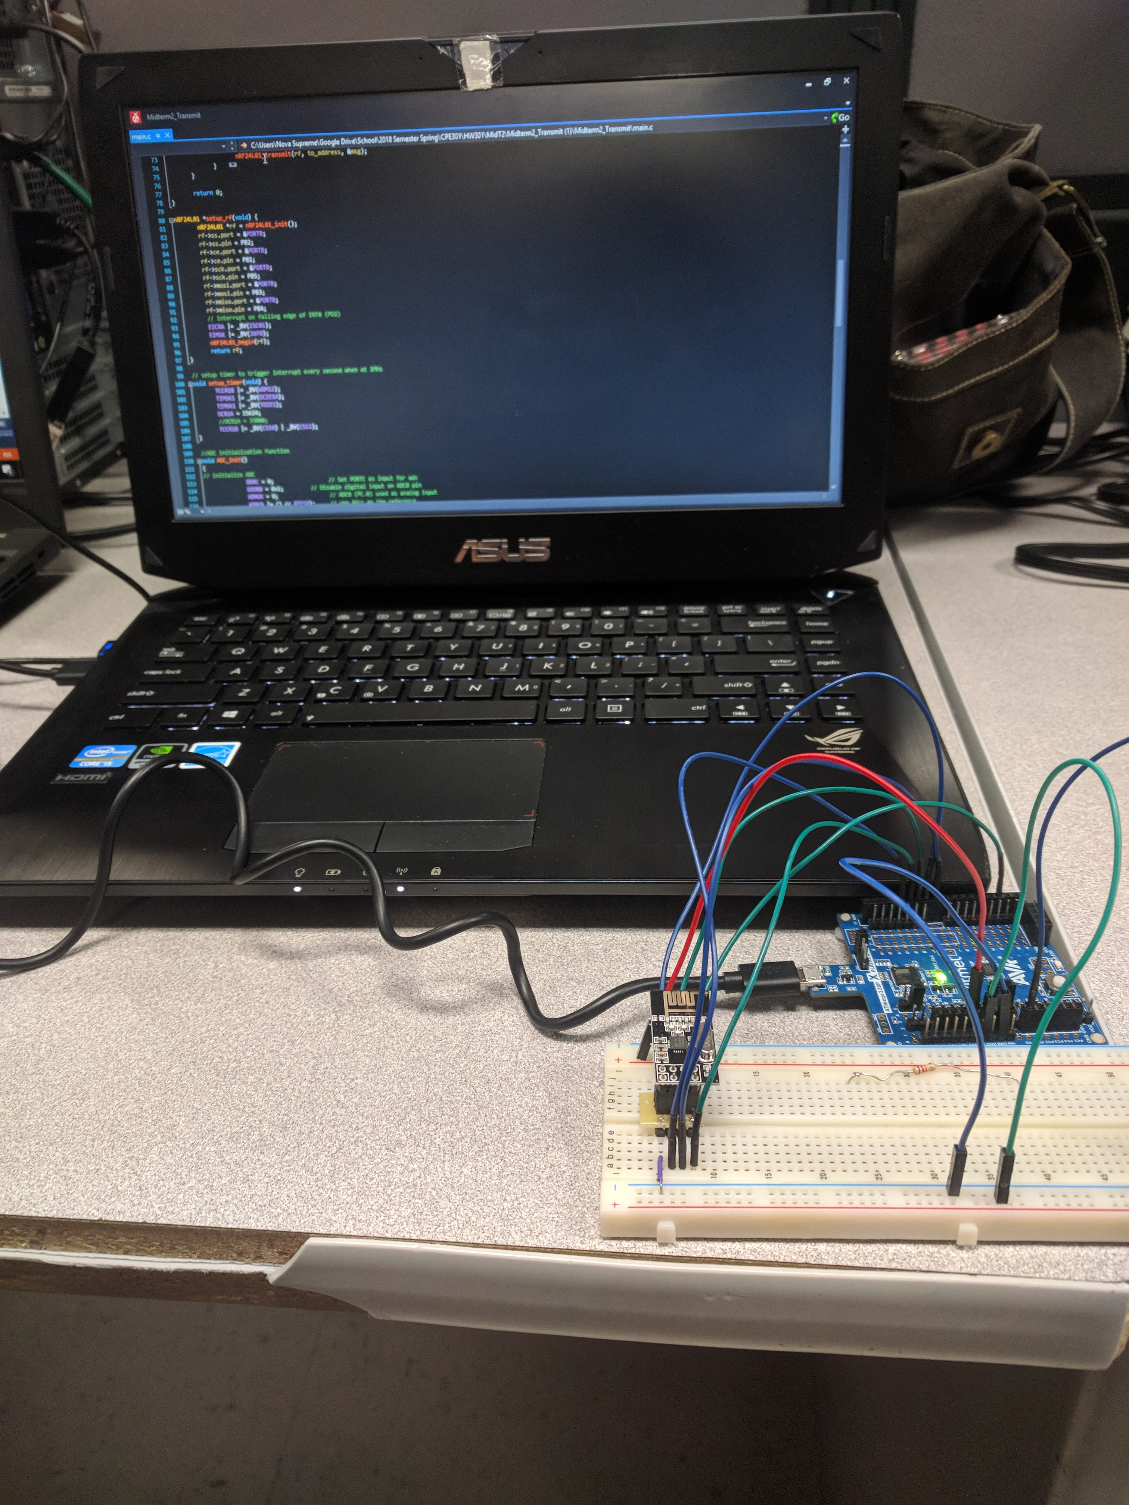

Figure 6: Sender

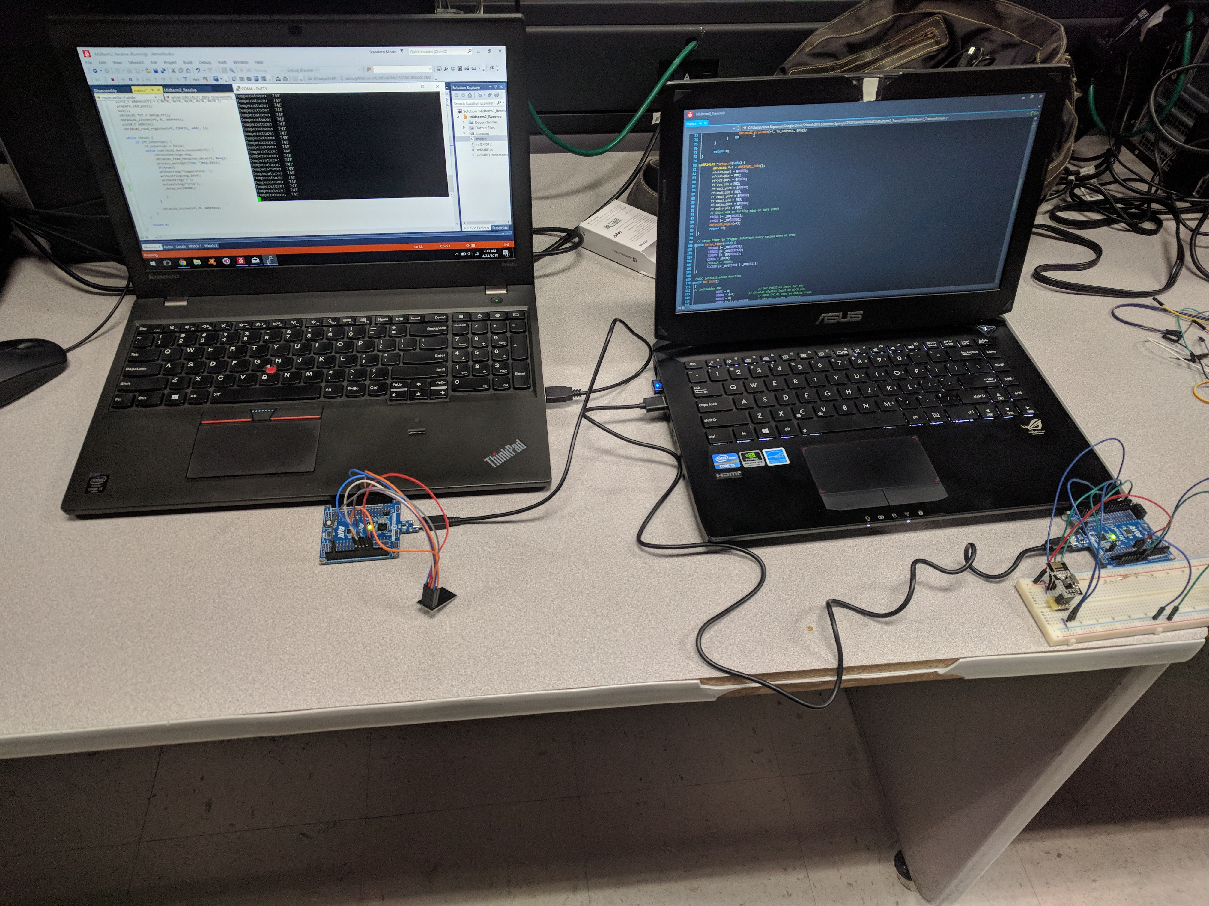

Figure 7: Sender and Receiver

1. **VIDEO LINKS OF EACH DEMO**

<https://www.youtube.com/watch?v=PoDQDhIuC0Q> – Trace Stewart Video

<https://www.youtube.com/watch?v=0nGb7eek_Jw> – Guillermo Gálvez Video

1. **GITHUB LINK OF THIS DA**

**Student Academic Misconduct Policy**

<http://studentconduct.unlv.edu/misconduct/policy.html>

“This assignment submission is my own, original work”.

Trace Stewart

Guillermo Galvez